TEST SUMMARY REPORT

TABLE OF CONTENT
1. Report Description
2.Application Overview
3.Testing Objectives
4.Scope
4.1 In Scope
4.2 Out of Scope:
5. Metrics:
6. Test Environment & Tools
7. Areas for Improvement
8. Best Features To Keep Alive
9. Conclusion

1. Report Description

This document explains the various activities performed as part of Testing of
‘OPENCART’ application.

2.Application Overview
OpenCart is an online shopping platform that provides features such as user registration, login, account management, and a shopping cart system. The objective of this test plan is to ensure that critical user features such as Registration, Login, Change Password, and Cart Flow work seamlessly across two popular browsers: Google Chrome and Mozilla Firefox. The test will assess functionality, performance, user experience, and browser compatibility.

3.Testing Objectives

The aim of this testing phase is to assess the functionality and user experience of the Registration, Login, Change Password, and Cart Flow features on www.opencart.com across two browsers: Google Chrome and Mozilla Firefox. Additionally, the test aims to identify potential issues, suggest improvements, and highlight features that provide an optimal experience.

4.Scope

4.1 In Scope
- Registration:
Validating user registration by checking form field validation, error
handling, and email confirmation.
- Login:
Testing login using valid credentials, error messaging for invalid
credentials, and the "Remember me" functionality.

- Change Password:
Verifying that users can successfully change passwords, including
validation, email confirmation, and successful update.
- Cart Flow:
Ensuring users can add items to the cart, update quantities, view details, and proceed to checkout without errors

- Compatibility Testing:
Testing user flows on Google Chrome and Mozilla Firefox to ensure
consistent performance across both browsers.

4.2 Out of Scope:

- Security testing
- Performance testing
- Stress or load testing

5. Metrics:
No. Of test cases planned vs executed
No. Of test cases passed/failed

Metric | Chrome | Firefox | Total
Test Cases Planned | 73 | 73 | 146
Test Cases Executed | 73 | 73 | 146
Test Cases Passed | 66 | 66 | 132
Test Cases Failed | 7 | 7 | 14
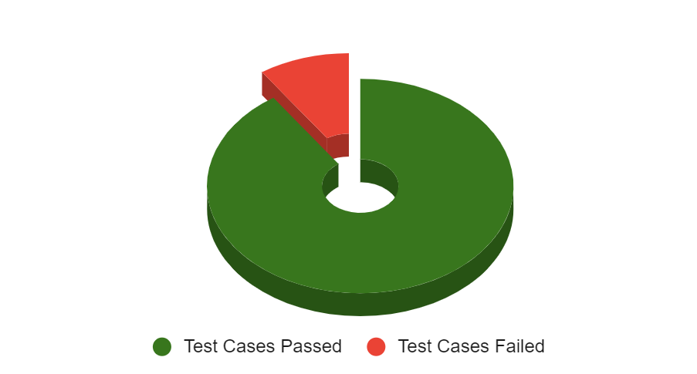

Status Distribution- Feature Wise

Feature | Registration | Login | Change Password | Cart Flow | Total
Passed | 28 | 11 | 10 | 19 | 48
Failed | 4 | 1 | 1 | 1 | 8
Not Executed | 0 | 0 | 0 | 0 | 0
Total | 32 | 12 | 11 | 20 | 56

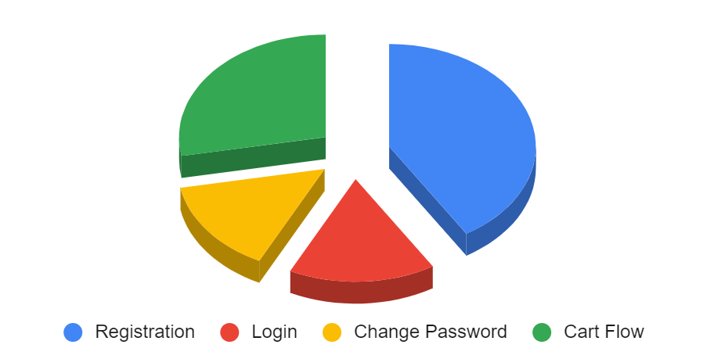

Defect Summary (Severity-Wise)

Severity | Count
Critical | 2
Major | 4
Minor | 0
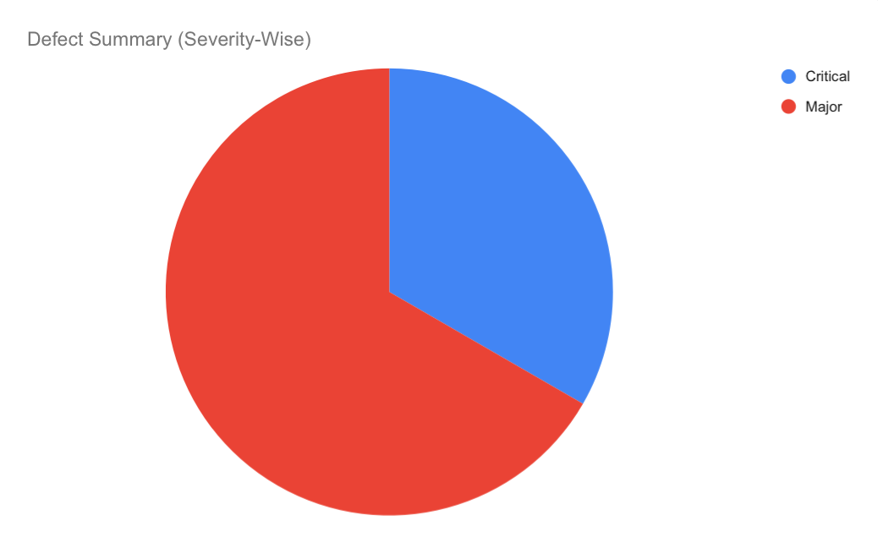

e) Defect Distribution (Function/Module-wise)

Function/Model | Critical | Major | Minor | Total
Registration | 0 | 2 | 0 | 2
Cart Flow | 2 | 1 | 0 | 3
Search Functionality | 0 | 1 | 0 | 1

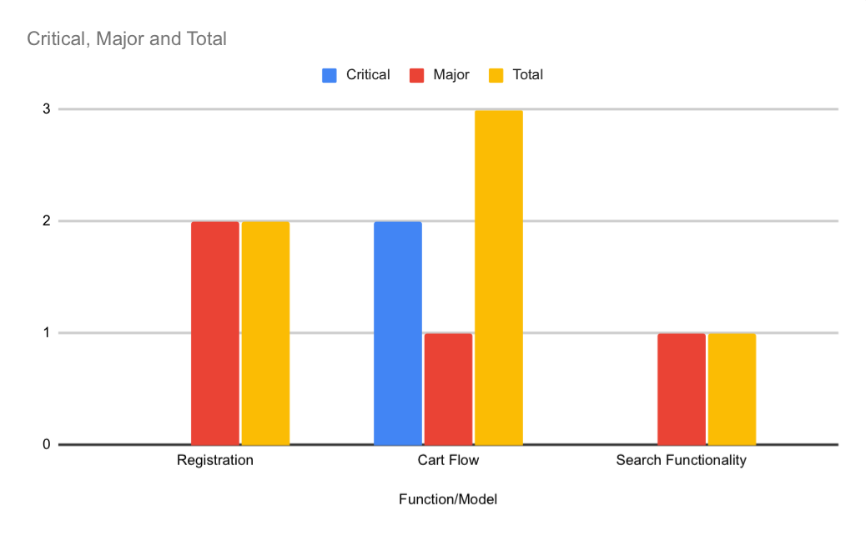
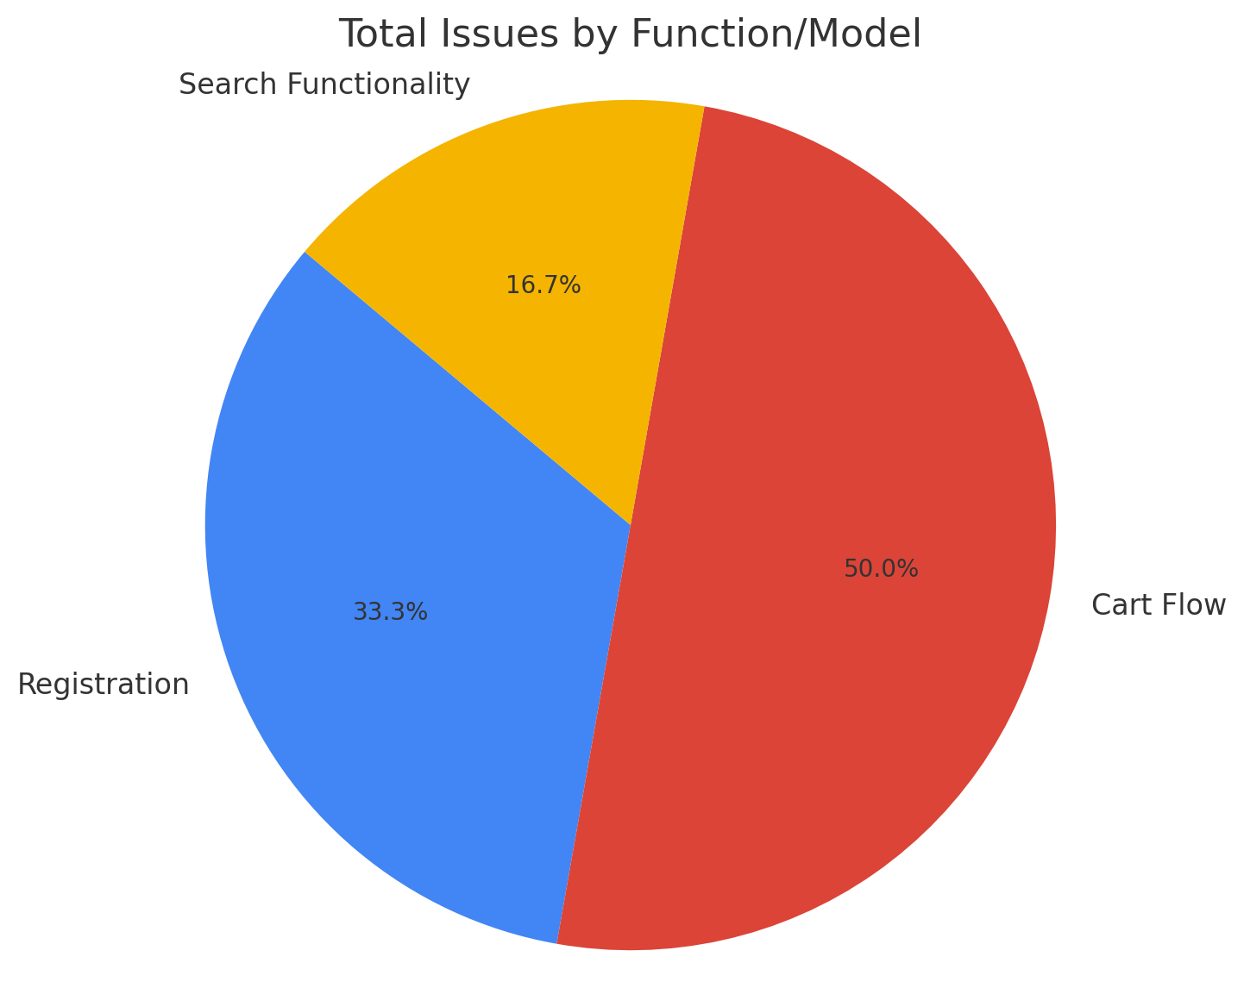

6. Test Environment & Tools

- Google Chrome (Latest version)
- Mozilla Firefox (Latest version)

7. Areas for Improvement:
- Page Load Times: Speed optimization, particularly for the Cart Flow, is essential to avoid delays that could negatively impact the user experience.
- Mobile-Friendly Testing: Though not in scope for this phase, future testing should include mobile compatibility to ensure a seamless experience on all devices.
- Clear Error Messaging: Improve the clarity of error messages for Registration and Login by providing user-friendly, detailed feedback.
- Password Reset Process: Simplify the password change and recovery process by reducing steps or making it more intuitive.
8. Best Features to Keep Alive:
- Simple Registration Process: The streamlined sign-up process is a key strength and should be maintained for its ease of use.
- Smooth Cart Flow: Ensuring the Cart Flow remains glitch-free across browsers is important for a positive user experience.
- Security Features: Strong authentication and password protection mechanisms build user trust and should remain a priority.
- User Interface (UI): The clean, intuitive design contributes to usability and should be kept consistent.

9. Conclusion

In conclusion, the testing of the OpenCart application successfully identified several key issues in the critical user flows of Registration, Login, Change Password, and Cart Flow, across both Chrome and Firefox browsers. A total of 146 test cases were executed, with 132 passing and 14 failing. The defects identified included 2 critical and 4 major issues, primarily affecting the Cart Flow and Registration features. These findings will help improve the application's functionality and ensure a more seamless and reliable user experience moving forward.

